- Gather Stakeholders
It’s recommended that schools and their OST programs include as many staff, families, students, OST providers, and community partners as possible in the conversation regarding a vision for SEL. Larger communities may wish to hold several sessions or convene focus groups to get a wide variety of viewpoints. When time is limited, consider providing the questions below in advance.

- Ask Individuals to Identify Their “Personal Why”
Before groups of stakeholders can identify their shared vision, it’s helpful for each individual to consider their own reasons for choosing to work with youth. Using the questions below as a prompt, ask individuals to use sticky notes to note their hopes for youth and why they feel that creating safe, supportive, and engaging environments through social-emotional learning is important:

- Why did you decide to go into education or work with youth?
- What do you believe about youth?
- Why is it important that you are a part of this community?
- What is your dream for our youth?

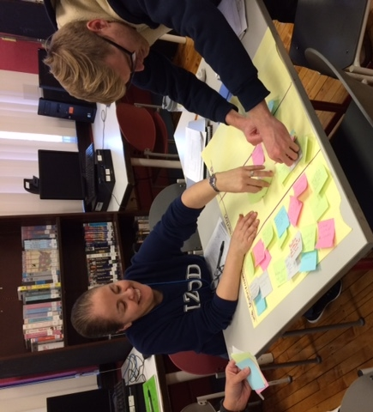

The school community at Spry Elementary in Chicago, IL reflect on their “personal whys.”

- Ask Small Groups of Stakeholders to Identify Their “Shared Why”
Next, break the stakeholders into small groups. Ask participants to review the sticky notes they created in step 2 and use the guiding questions below to identify similar themes in each group.
- What are our core values? How are our values similar and different when discussing school and OST programming?
- What are our priorities? How much is OST programming a part of our school priorities?
- What does success mean for our youth?
- What qualities and skills do we hope all youth possess upon leaving our school and OST programming?
- What culture and climate do we want to build?

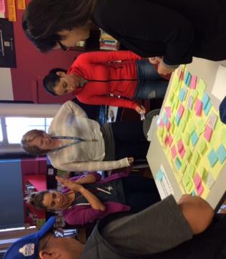

The school community at Spry Elementary in Chicago, IL, break up into small groups
to identify common themes in their core values and priorities.

- Incorporate Group Feedback into a Single Shared Vision
The SEL Leadership team can use each group’s “shared why” to draft a shared vision that represents all stakeholder groups. Then stakeholders can vote whether to accept or revise the draft. If the stakeholders vote to revise, the SEL Leadership Team can organize a revision session with all stakeholders. With patience and collaboration, it’s possible to create a shared vision that captures the spirit of the entire community including teachers, OST program staff, parents and community stakeholders.

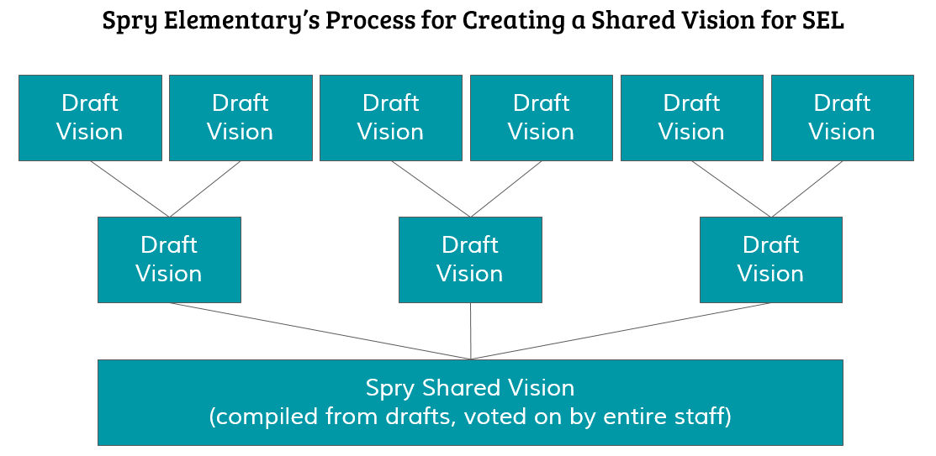

The community at Spry Elementary in Chicago used a three-level consensus-building process. Once individuals engaged in preliminary guiding questions, six small groups formed and drafted shared visions. Those six groups then combined into three larger groups and merged their shared visions. Those three larger groups then finalized a shared vision for SEL.

- Make your Shared Vision Visible and Actionable
It’s important to make your vision visible, prominent, and actionable. Some practices include painting it on the entry hall wall or putting it on the school’s and OST program’s websites, letterheads, and T-shirts for field day and other regularly occurring events. Launch the idea in creative ways that will appeal to the community to create momentum. Making your shared vision visible and useful is key in its sustainability. Refer to your shared vision for SEL frequently in:
- Staff meetings
- Internal email communications
- Communications with families and your network about new projects and initiatives
- When hiring and orienting new staff
- Making your shared vision visible and useful will be key in its sustainability.

The time needed to develop a shared vision will differ from community to community. Plan to dedicate at least one hour to steps 1-3 of the activity above. The SEL team can then complete steps 4 and 5 after the group discussions conclude during one or two SEL team meetings.

