- During an all-staff meeting, present the shared vision that was previously developed.
This all-staff meeting would ideally include OST program staff, alongside teachers and other school support staff. If there are no immediate opportunities for school and out-of-school-time staff to meet jointly, solicit out-of-school-time staff ideas and school staff ideas in parallel, separate processes, bringing all feedback together at the end.

Ask the staff to think about three to five positively stated action statements about how we will all work together to achieve our shared vision and nurturing of adult SEL. These may be statements like “Be professional” or “Be restorative” or “Seek to understand.” These guiding questions can help establish these action statements:
- What mindsets and behaviors will help us grow as a school community?
- What do we all need to do to be effective in our positions?
- What does our vision look like in action?
- What skills and qualities will we need to model?
- What qualities are important for our professional integrity, ethical responsibilities, and professional focus?

- Invite staff to think about what each statement might look and sound like when they’re interacting with their peers, youth and their families, and community partners. Be sure to prompt school staff to think about their interactions with OST program staff and vice versa. Ask everyone to write their ideas on separate sticky notes (see Figure 1).

- Once all staff have had the opportunity to share their ideas, the SEL team will create a concise list of agreements. Staff will then be able to reflect upon the list to ensure that everyone’s ideas were accurately captured and that the list fully embodies the group’s intent.

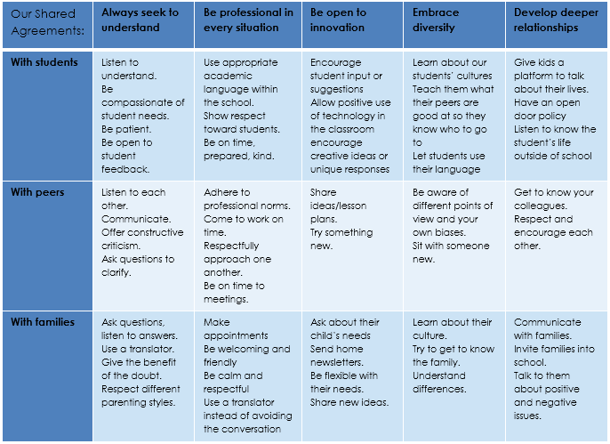
- Post these agreements in the school staff lounge, the school’s main office, the OST program space, and other common areas. To keep these shared agreements relevant throughout the year, refer to them in staff meetings, include them as part of meeting agendas, and leverage them during conversations between teachers and administrators as well as between OST leadership and program staff.
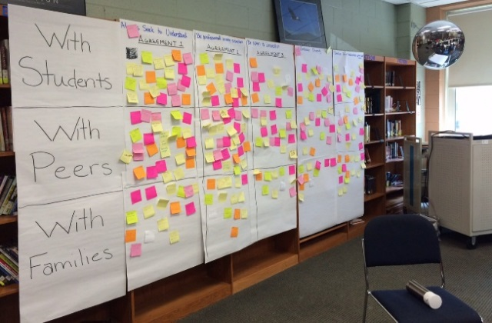
Figure 1. School Example: Staff Shared Agreements.

