Developing Shared Class Goals

Purpose: Provide structures for students to develop, share, and reflect on personal and classwide goals to create a community of learners.

Creating Class Academic, Social or Emotional Goals
Creating collective goals can help develop a supportive learning environment by creating a task that requires cooperation and helping students see how their successes are linked.

Try this:
- As a class, brainstorm ideas for a goal. For example, students may decide that they want to collectively read 100 books or learn 50 new vocabulary words. Gather these on chart paper.
- Take a class vote on goals, reminding students that this is just the first one of the year. There will be opportunities to work on others!
- Discuss when they will reach the goal and how they can support one another so that everyone feels empowered to contribute (weekly book talks to recommend good books, vocabulary flashcards, etc).
- Check in and track progress along the way to keep students motivated.
- Celebrate when you reach the goal!

Framing is important to make this an inclusive experience. The goal is to build a sense of community achievement in which students know that they can help one another and learn from their peers. Be sure that goals are realistic and allow students to participate at an appropriate level.

Setting Goals in Problem-Solving Conversations
At times, your class may confront challenges that require students and teachers to do things differently. For example, your class may be consistently late for lunch or leave the room a mess after hands-on activities. This is an excellent time to “huddle up” around goal-setting. Have students come together in a circle.

Try this:
- Tell students the problem as you see it or provide students an opportunity to share if they themselves identified an issue. Briefly touch on why this is an issue to build social awareness (e.g., The lunch staff works really hard to make sure everyone has time to eat. When we are late to lunch, we throw off their schedule).
- Ask students to pair up and discuss why the problem happens (Is there enough transition time? Are the routines clear?) and a possible solution.
- Bring students back together and ask them to share out as a class. Respect students’ responses by keeping an inquiry stance. You could say, "That’s interesting. Tell me why you think that." Right now, you are just brainstorming.
- As a class, determine one or two strategies to implement and decide when you will come back together to see how the class is doing.
- Check in and track progress along the way to keep students motivated.
- Celebrate when you reach the goal!

This is an excellent time to help students develop relationships skills. You may have them brainstorm and role-play strategies for keeping one another accountable to the goal. Examples include offering to help a student pack up to get to lunch on time or gently reminding one another about where class materials are stored. This is also a great time to get students thinking about how personal talents (being organized, being a good communicator) can help the class achieve shared goals.

Individual Academic, Social, or Emotional Goals
Having students set individual goals can also help to create a sense of ownership over academic, social, and emotional learning.

Student Goal-Setting Worksheet

Create community support by having students partner up with a “growth buddy.” Have them take turns sharing their goals and potential obstacles and how they might respond to those obstacles. You might also share growth-oriented language for students to use when they check in on their progress. Growth-oriented language could include statements such as:

- “You aren’t there yet, but you can do it!”
- “What strategies have you tried?”
- “What will you try next?”

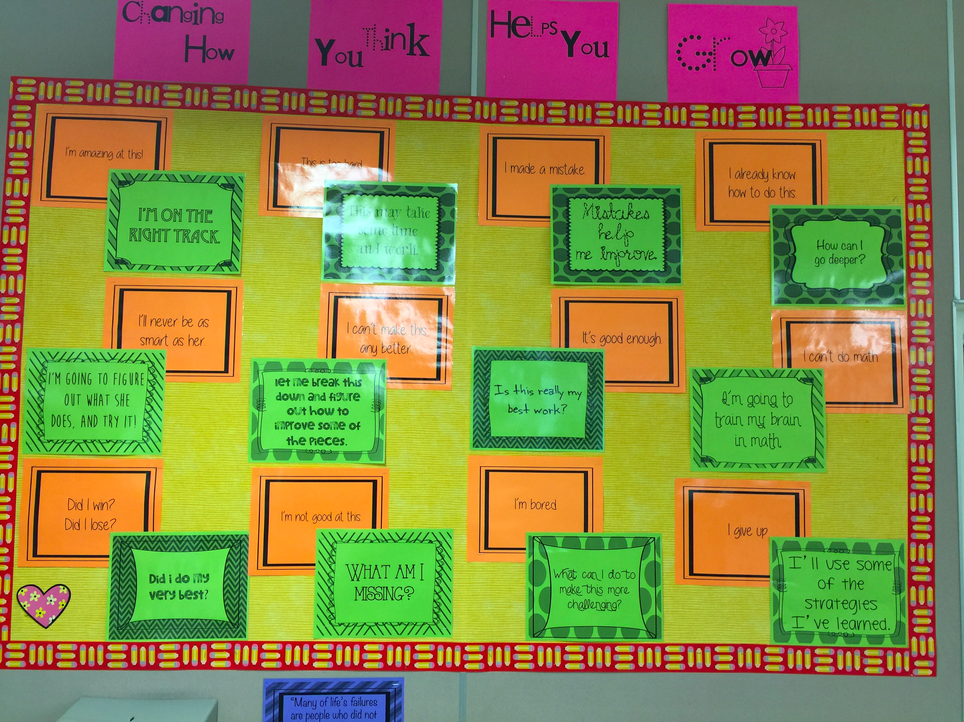

Acknowledge Achievement
Find rituals for honoring the achievement of individual and collective goals. This is not a reward. Examples might include
- Making time during circles for students to share a goal they achieved and how they overcame obstacles.
- A special note home to parents when students achieve an important milestone towards their individual goals.
- A whole class cheer or dance (depending on the grade level) when a classwide goal is achieved.
- A special all-school announcement when a classwide goal is achieved.

