Driver Diagram Generation Protocol

The purpose of this protocol is to generate a shared “theory of action”
to drive a team’s improvement efforts and ultimately achieve the aim.

Note: Driver diagrams are not intended to be set in stone. Your team’s theory of action should evolve as you learn more about the problem/gap you want to address, the change ideas you are trying, and how best to achieve your aim. We encourage teams to revise your driver diagram to reflect your most current thinking/focus, and to keep track of versions 1.0, 2.0, etc. so you can reflect on the evolution of your learning.

Norms:
- “Yes, and”... the goal is to generate lots of ideas, not fixate on one
- Embrace “definitely incomplete; possibly incorrect”
- Share the air

Some helpful definitions:
- Aim = what you want to accomplish for whom by when (samples below)
- Primary Driver (the what) = what you need to focus on to achieve your aim (i.e. financial literacy)
- Secondary Driver (the where) = where in your system (the existing structures/processes) you should focus your energies to effect the primary driver (i.e. parent workshops)
- Change Idea (the how) = what you can try and test/refine (i.e. Families complete the FAFSA together at the monthly parent meeting)

Protocol:

- Clarifying/Refining our Aim Statement (5-10 minutes)

As a group, craft/refine your aim: What do you want to accomplish, for whom, by when?
It can help to begin by having each person, individually or with a partner, craft an aim statement. Follow this with a share-around where each person/partnership shares their aim with the group. Then the group can adopt/adapt from these to create an aim statement everyone feels good about. Write your group’s aim statement on the left side of your poster.

Some things to consider:
- Is your aim measurable? To help ensure your aim is measurable, it can be helpful to ask yourselves this question: “If X was the best it could be, what would it look like?” It can also help to get baseline data related to the issue/gap your team is working on.
- Some sample aims:
  - By Spring 2015, all HTHNC seniors will apply to a 4-year college.
  - By the end of 15-16, CAT HS will decrease our % of students who need remedial Math & English courses in college from 85% to 50%.
  - By May 2016, 60% of seniors at John Muir HS will score a 3 or 4 on the first reading of their senior research paper (compared to 20% last year).

- Identifying Primary Drivers (20-30 minutes)

  - Individual (no more than 5 minutes): Each person identifies the top 4 drivers (i.e. high leverage areas) they think the team needs to focus on to impact the aim, and writes each driver on a separate index card.
    - Facilitation Move: It can help to think of drivers as X in the following statements: “If we figured out X, we could achieve our aim” or “If we don’t figure out X, it is unlikely we would achieve our aim.”

  - Share Around & Cluster: Each person shares their favorite driver with the group. If others wrote down a similar driver, group these cards together on the table.
    - Facilitation Move: As your group shares and clusters, it can be helpful to organize the “stacks” with the most cards to the top of the table, and those with the least to the bottom. This gives the group a visual indicator of which drivers might be most important.

  - As a group, select 3-5 drivers that you think are essential for impacting your aim. Write those drivers on your driver diagram poster. This is your “theory of action” (i.e. if you could move these drivers, you could achieve your aim).
    - Questions for the team to consider:
      - Is this driver specific enough that we all understand what to focus on?
      - Is this driver impactful enough that it will move the work forward?
      - Is this driver within our locus of control, meaning we can do something about it? (i.e. Poverty is real, but may not be a helpful driver. However, Family Support could be an important driver and signals a way of working with families to reduce the effects of poverty.)
      - Are these drivers necessary and sufficient for achieving our aim?
      - Which driver do we think is our greatest lever for change? (Star this one.)

3. Identifying Secondary Drivers (5-10 minutes)
Secondary drivers articulate “where” in the system (i.e. what structures and processes) you can
focus your efforts to impact the primary drivers. Identifying these can help focus the team’s efforts
and lead to more concrete change ideas. For example, helpful secondary drivers may be Advisory,
Professional Development, Number Talks, Classroom Meetings or Master Schedule. As a group,
identify 3-6 secondary drivers and add them to your driver diagram, drawing arrows to show how
they impact the primary drivers.

4. Generating Change Ideas (20-25 minutes; you will need another poster for this part.)

  - Individual Brainstorm (3 minutes): What could we try that would impact the drivers we identified? What does the research say we should try? Where is this happening well already (bright spots), and what are they doing? Write each idea on its own post-it.

  - Chart Your Change Ideas (15-20 min.): On another large chart paper, draw an effort vs impact axis (see example below). Using your best collective guess, place each of the change ideas in the quadrant it fits best. Start by having each person share their favorite idea, and cluster similar ideas as you continue to share out. It can be helpful to ask:
    - How much effort (time, energy, resources) would it take for us to test this idea?
    - If we are successful what is the size of the likely impact?
    - Will this idea impact issues of equity in our system?
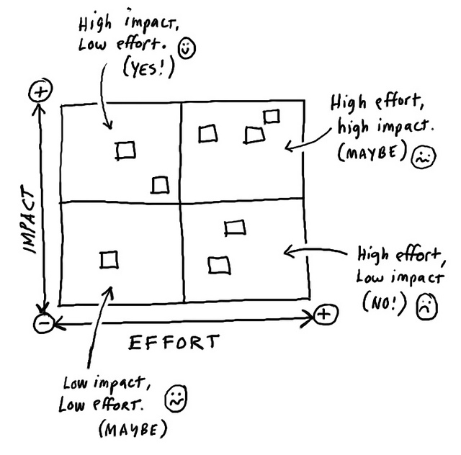

  - Identify high leverage change ideas (5 min): As a group identify 4-6 change ideas that you think are most impactful, that you could get moving on quickly, and that are within your team’s locus of control (i.e. usually those in the upper two quadrants). Add these change ideas to your driver diagram, drawing arrows to show how they are aligned to the secondary drivers.
    - Question for the team to consider: What do we notice about the alignment (or lack of) between our change ideas and drivers? (If your change ideas don’t align to your existing drivers, this could suggest a new driver is needed. If you have a driver without any change ideas, this driver may not be helpful to your current “theory of action”.)

5. Debriefing the Process (5 minutes)
Group members discuss the following questions:
- How well did we do with upholding the norms and sticking to the protocol?
- Was this protocol helpful for identifying high leverage drivers and change ideas?
- What worked well about this protocol? What could be improved?

This protocol has been created by the High Tech High GSE Center for Research on Equity and Innovation.

