TOOL: Creating Staff Shared Agreements

Shared agreements describe how all staff will contribute to the realization of this vision and maintain a work environment that enables everyone to stay committed.

The co-creation of staff shared agreements also serves as a model for educators as they prepare to facilitate a similar process with their young people. Engaging in the development of shared agreements helps all staff envision how they will model social and emotional competence throughout the year.

For SEL teams that are focused on building systemic SEL beyond the school day, the process of developing shared agreements is a powerful opportunity to bring together partners from different contexts. Engaging in the process of co-creating shared agreements allows staff from different organizations to set the precedent that they will be collaborating to build the SEL foundation they collectively want for their young people, which is consistent as they move throughout the day. Therefore, there are reminders included throughout this protocol for SEL teams to be mindful of how partners that work with youth in various capacities are engaged in this process.

- During an all-staff meeting, present the shared vision that was previously developed. If possible, include out-of-school time staff and other partners in this meeting. If not, gather their input f in a parallel, separate process.
As our vision becomes reality, what should we…

HEAR

SEE FEEL

- Ask staff to describe what they would see, hear, and feel as the shared vision becomes reality. Organize responses in a Y-chart. To encourage responses from all staff, give time for staff to think and write before sharing and consider using a talking circle, collecting sticky notes, or breaking into smaller groups for this step.

- Once staff have arrived at a shared understanding of how the SEL vision looks in action, work as a group to define how all staff contribute to realizing the vision. Set up chart paper around the meeting space with prompts on each. Provide each participant with a marker to write responses, put a check mark next to responses they agree with, and respond to the responses of others. For this “chalk talk”, participants should move around the room silently and at their own pace, with enough time to visit and revisit each prompt. If you have a large group, use multiple pieces of paper for each prompt to avoid crowding.
Suggested prompts:
- What kind of work environment will help us stay committed to our vision?
- What mindsets, skills, and SEL competencies will we need to embody to move forward toward our vision? *
- How will we move toward our vision through the way we communicate and interact with youth?
- How will we move toward our vision through the way we communicate/interact with families?
- How will we move toward our vision through the way we communicate/interact with each other?
- How will we hold each other accountable to our agreements?

- After all staff have spent time with each prompt, ask them to choose a poster that feels most powerful to them, and work with others who chose the same poster to distill written comments down to a few core action-oriented statements. Ask each group to record these on paper or type and send them to the facilitator who will organize them into a central document to be shared with everyone or projected in the room.

- As a group or later as an SEL team, combine similar statements and revise to reduce to 3-7 broader agreements that encompass all input. Share these statements back with all participants (and remember to include out-of-school time staff and other partners). Invite further input by providing a window of time for staff to think about and respond to this list of agreements by using an exit slip, an anonymous survey, or reconnecting later with smaller, more focused groups or teams. By taking time to include everyone at this stage, shared agreements become more meaningful and a better standard for accountability.
- Finalize the staff shared agreements and share these with staff and volunteers as well as youth and their families. Post agreements in common spaces in the school and OST program spaces and keep them relevant throughout the year by referring to them in staff meetings, including them as part of agendas, and leveraging them during conversations between staff and administrators.
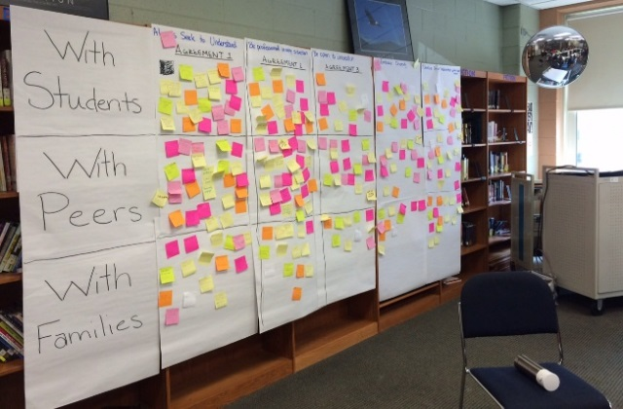
Figure 1. School Example

A Chicago high school brought their staff together to develop a common understanding of how they would carry out their shared agreements through the way they interacted with students, colleagues, and families. The SEL Leadership Team used their feedback to complete a finalized version of their shared agreements.

