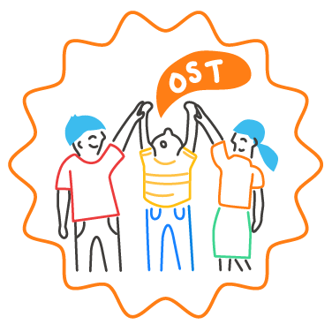
Key Responsibilities of an SEL Team Member

Summary of position:
Members of the SEL team will model social and emotional competence throughout the school community and work to advance the shared SEL vision and mission.
Team members can include teaching staff, administrators, support staff, students, parents and caregivers, site-based out-of-school-time providers, or any member of the school community.
Primary functions:
- Ensure the fulfillment of assigned roles and responsibilities in support of systemic SEL implementation.
- Advance the school community’s SEL goals.
- Engage in regular reflection and analysis of SEL-related data to monitor progress and make real-time pivots for continuous improvement.
- Regularly communicate the importance of social and emotional learning throughout the school community and model SEL competencies.
- Assist the team lead in developing learning opportunities about SEL for the school community.
- Communicate regularly with the constituent group that the team member represents. For example, a team member who is a first grade teacher might be responsible for communication with other first grade teachers about SEL.
Qualifications:
A highly qualified SEL Team Member will have:
- A passion for promoting social and emotional learning as an essential part of every child’s education.
- A strong continuous improvement mindset and the ability to lead others in reflecting on current practice and making improvements.
- Willingness to examine and discuss school data in equity-minded, solution-oriented ways.
- Flexibility to attend team meetings regularly.
- Familiarity with the CASEL Guide to Schoolwide SEL.

