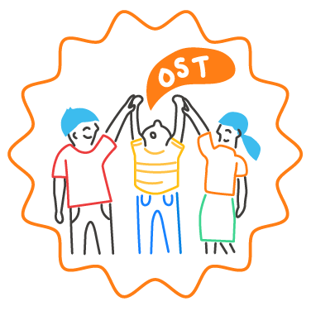
Sample SEL Team Meeting Checklist

Before
❏ Schedule meetings in a regular, repeating pattern, at least once monthly, for the entire school year
(example: every other Tuesday). When determining meeting times, consider the work schedules and responsibilities of various team members.

❏ Develop an agenda in advance that reflects the SEL goals and action plan.
❏ Request additional agenda items from team members.
❏ Gather and summarize data for the team to use to monitor progress toward goals and make real-time pivots for continuous improvement.

❏ Send out the finalized agenda and a meeting reminder to team members at least one day in advance.
❏ Choose a welcoming and closure activity to be used at the beginning and end of the meeting.
During
❏ Use a relevant welcoming inclusion activity to begin the meeting.
❏ Review the list of action items from the previous meeting and update progress.
❏ Review and reflect on relevant data for continuous improvement. Consider the time it might take to talk through the story that data tells about implementation progress.

❏ Collaborate to make progress on planned action steps to meet SEL goals.
❏ Determine tasks that need to be completed and assign team members and due dates to each.
❏ Agree on what needs to be communicated to or asked of the larger school community.
❏ Agree on and capture what needs to be addressed at the following meeting.
❏ End with an optimistic closure.
After
❏ Send meeting minutes and next steps to the team and other stakeholders.
❏ Have team members communicate agreed-upon information to their stakeholder groups.
❏ Remind team members of their assigned action item(s)

