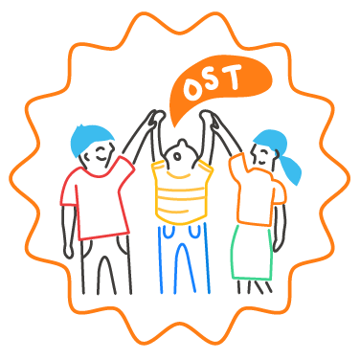
Create a Professional Learning Plan

Purpose: This chart can be used to organize a customized professional learning plan for your staff that is clearly tied to the school community’s goals for SEL, can be assessed for effectiveness throughout the year, draws upon available resources, and includes intentional follow-up to ensure that new practices are sustained and supported over time. In contrast with Foundational Learning, this tool is to plan specific, ongoing learning experiences that will support staff in carrying out the SEL implementation plan and moving the school community closer to accomplishing core SEL goals.

 | LEARNING OBJECTIVE | MEASUREMENT | PROFESSIONAL LEARNING OPPORTUNITIES |  |  | FOLLOW-UP STRATEGY | DATES/OWNERS
SMARTIE  Goals | What do staff members need to know and be able to do to achieve this goal? | How will we measure whether we have met this learning objective? How and when will we monitor progress? | What professional learning opportunities from the district or network can support this goal? | What other professional learning is available to support this goal (e.g., conferences, webinars, etc.)? | What online or print resources can we build from to prepare our own professional learning? | How will we provide follow-up support for all and focused support as needed? | When will this happen throughout the year? Who will take the lead on making arrangements/ preparing?
SEL Goal 1:
SEL Goal 2:
SEL Goal 3:

