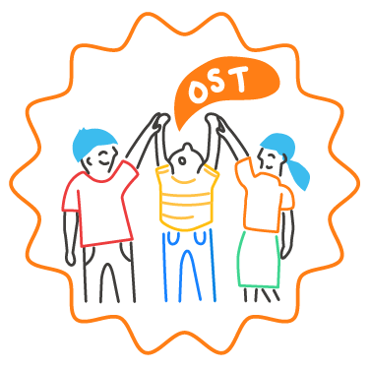
Develop SEL Team Working Agreements

Purpose: By taking the time to collaboratively develop clear working agreements, the SEL team sets the stage for a sustainable division of responsibility, productive meetings, and a team culture that values differences of opinion and inclusion. This tool outlines a process for developing team working agreements.
Steps:
- Provide sticky notes for each member of the team. Write the questions in the box below on a poster, screen, or board where everyone can see them, and give time for all team members to answer each question on sticky notes.
What habits will help our meetings run efficiently and effectively?
What habits will make members of this team feel motivated and want to stay involved?
What habits will help this team achieve the SEL goals of our school community?
How should this team ensure that all stakeholder views are sought out, valued, and understood?
What should this team do if we aren’t in agreement?
How should team members hold each other accountable for following these agreements?

(Each question should be answered on separate sticky notes, but each team member can write more than one response note for each question if they choose).
- Gather the groups’ response notes into a separate pile for each question. Assign a different team member or pair of team members to collect the pile of responses for each question. Each individual or pair should then organize the responses into piles that express similar ideas.

- For each question, the team member or pair reads aloud all responses in the order they have organized them. After all responses to an individual question have been read, discuss the following questions as a group.

Are there any responses that we don’t fully understand? (If so, invite team members to expand on their response).
Are there any points of disagreement or contradiction among these responses?
How could we synthesize these responses into 1 or 2 statements about how we aim to work together as a team?

- Follow this process for each question until you have a list of statements that summarizes the points of agreement about how the team should function and interact. It is recommended that you settle on 10 or fewer working agreements. Some statements will likely be more logistical in nature (e.g. End meetings on time with clear action steps) while other statements will likely be about ways of being and interacting (e.g. Make space for opposing views – even if all team members agree on a course of action, consider which stakeholders may have a different perspective).

Here are some examples of team working agreements:

Begin and end on time
Rotate responsibilities
Be mindful of all learning contexts within our community
Use meeting time effectively and efficiently
- Send out agenda and reminder 2 days in advance
- Agenda items must connect to our core SEL goals
- All members can contribute agenda items
Step up when you can, step back when you need to
Celebrate progress, both big and small
Approach our work with a lens of equity
Use data regularly to track progress and make decisions
Prioritize student perspectives
Don’t assume agreement
Stay solution-oriented
Approach differences with an open mind
Seek to understand, not to judge
Address “Ouch” and “Oops” moments directly, either as a group or one-on-one
Communicate SEL updates to staff monthly, to students and families quarterly
Bring snacks to meetings!

“Ouch” moments – when others say or do something that hurts, offends, upsets, or belittles an individual. “Oops” moments – when an individual says or does something they regret, and worries they may have hurt, offended, upset, or belittled someone.

