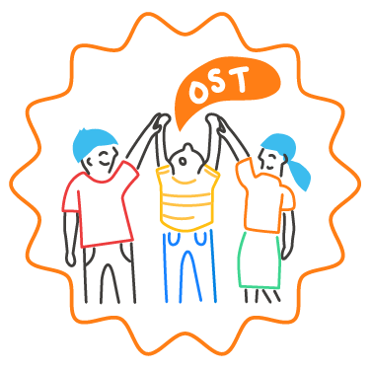
SEL Team Self-Assessment
Regularly reflecting on team functioning and effectiveness helps the team continuously improve. This self-assessment helps provide a structure for team reflection and can be used frequently throughout the year. As a full team, discuss each of the items below, noting any areas of strength and areas for improvement. After reflecting on each item, discuss next steps, including what areas to prioritize and actions you’ll take to improve and celebrate the team.

 | Area of Strength | Area for Improvement | Discussion notes
1. SEL team members, including at least one administrator, represent diverse backgrounds and areas of expertise.
2. The team meets at least once monthly, and meetings are regularly attended by all team members.
3. All team members have a clear understanding of the team’s shared purpose, and know how their individual roles and responsibilities support team goals.
4. Team working agreements are established, regularly reviewed, and followed by all team members.
5. Team members have frequent opportunities to get to know one another and build positive relationships.
6. Purposeful meeting agendas are planned in advance and aligned with the school community’s SEL implementation plan and goals. (See Preparing SEL Team Meeting Agendas)
7. Team meetings are efficiently-run following the planned agenda with clear and documented next steps and action items.
8. The team addresses schoolwide systems, structures, and practices rather than individual student needs.
8. The team regularly collects and/or has access to data that is relevant for monitoring progress toward SEL goals.
9. The team regularly uses a structured protocol to reflect on data and make real-time pivots for continuous improvement.
10. The team utilizes a democratic process for decision making that ensures all perspectives are heard (e.g., voting or consensus). Team consults students, families, all staff and core out-of-school-time providers when developing policies that impact all.
11. The team has an effective strategy to communicate data, decisions, next steps, and celebrations to staff, families, community partners, and students on a regular basis.
Next steps: |  | Date:

